Sprint Plan 3

**Product:** SquadUp

**Team:** The Big Ballers

**Completion date:** July 23rd

**Revision number:** 1.0

**Revision date:** 7/17/2018

**Goal:**

Create a more polished aesthetic. Implement a park view page, account profile page as the account login redirect, a search park page with a button that can add an event, and an event list page.

**Tasks for user stories:**  User Story 1: As a user, I want all pages to be functional to use the web app as intended. (Story Points: 8)

* + Task 1: Implement a park view page. 2 Buttons, 1 List.

**Hours estimated:** 6

* + Task 2: Implement an account profile page.
    - **Hours estimated:** 5
  + Task 3: Implement an event list page.
    - **Hours estimated:** 5
  + Task 4: Implement an add-event page
    - **Hours estimated:** 3
  + Task 5: Change Landing page to be closer to mock up.
    - **Hours estimated:** 2
  + Task 6: Fix login page.
    - **Hours estimated:** 1
  + Task 7: Create a search/map page.
    - **Hours estimated:** 6

**Total Time for User Story**: 28 hours.

User Story 2: As a developer, I want to make API call to the backend, so that the client can get data. (Story Points: 8)

* + Task 1: Get event by ID, from the DB info.
    - **Hours estimated:** 2
  + Task 2: Get all events user is attending.
    - **Hours estimated:** 2
  + Task 3: Get all parks user is following.
    - **Hour estimated:** 1
  + Task 4: Get all parks by category.
    - **Hours estimated:** 1
  + Task 5: Get parks in radius.
    - **Hours estimated:** 1
  + Task 6: Get all events at park.
    - **Hours estimated:** 1

**Total Time for User Story**: 8 hours.

User Story 3: As a developer, I want to test every page for bugs and functionality to make the polish of the web app better. (Story Points: 5)

* + Task 1: Test each page individually.
    - **Hours estimated**: 4
  + Task 2: Test the backend API calls
    - **Hours estimated**: 4

**Total Time for User Story**: 8 hours.

**Team roles:**

* Zahir Yahya: Front/Back end Dev
* Sean Woods: Front/Back end Dev
* Chuangbo Tong: Front/Back end Dev
* Shyaan Khan: Front/Back end Dev
* Collin Fulcher: Front/Back end Dev
* Tyler Frick: Front/Back end Dev

**Initial task assignment:**

* Zahir Yahya:
  + User Story 2
    - Get parks by radius
* Sean Woods:
  + User Story 1
    - Implement a working profile page.
* Chuangbo Tong:
  + User Story 1
    - Implement an add-event page.
* Shyaan Khan:
  + User Story 1
    - Fix login page.
* Collin Fulcher:
  + User Story 1
    - Implement an event list page.
* Tyler Frick:
  + User Story 2
    - Get events user is attending.

**Initial burnup chart:**

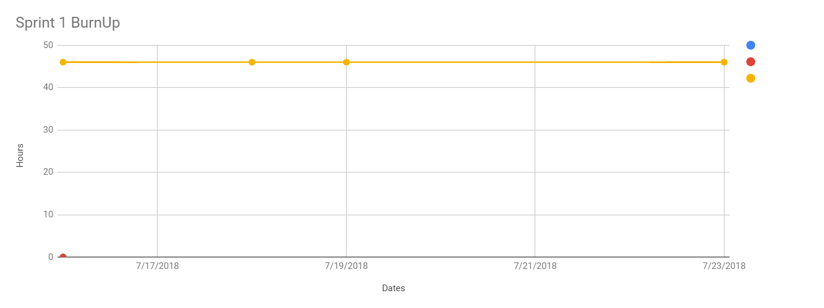



**Initial scrum board:**

https://trello.com/b/5uzWWJz7/squadup-scrum-board



**Scrum times:**

Monday after T.A. meeting: 1:00 PM

Wednesday After class: 12:30 PM

Thursday: After TA meeting 1:00 PM